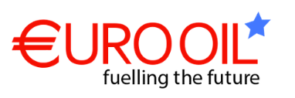
Fill in the Application Form & Direct Debit Mandate and return to eurooil@gmail.com.
PLEASE USE BLOCK CAPITALS Mandatory Fields are marked ***
Please enter details below:
Customer/Company Name**: _______________________________________________
Customer/Company Address**: _____________________________________________
________________________________________________________________________
________________________________________________________________________
Phone**: ________________________________ Mobile**: ________________________
Co. Reg.: ________________________________ VAT No.: _______________________
Accounts Email**: __________________________________________________________
Fuelcard information
Please specify total number of cards required: and the vehicle reg numbers to which the cards will apply...
Reg.#: _______________________________ Reg.#: _______________________________
Reg.#: _______________________________ Reg.#: _______________________________
Reg.#: _______________________________ Reg.#: _______________________________
Reg.#: _______________________________ Reg.#: _______________________________
Reg.#: _______________________________ Reg.#: _______________________________
Please Circle: Weekly Limit Per Card based on €350, €650, €1,300 or €2600 incl. Vat.
Please Circle Product Required: Derv Unleaded Add Blue Green Diesel
Signature: ____________________ Date: ______________________________

Full Name: ___________________ Position Held in Company ______________
Applegreen Network Fuel Card or Certa Network Fuel Card
Please circle Fuel card Network required.

